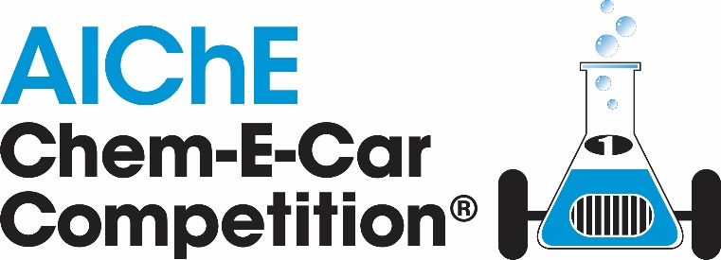

2021 Regional Virtual Competition Official Rules
 | Date | Checklist of Important Deadlines
□ |  | Find your Regional Conference at https://www.aiche.org/conferences/student  Review Rules, EDP Document & Safety Training information at www.aiche.org/chemecar  Submit questions at www.aiche.org/chemecarquestions
□ | February 19, 2021 | All Student Chapters must register to compete at www.aiche.org/2020chemecar
□ | February 20, 2021  -  May 08, 2020 | All teams are required to complete and submit an Engineering Documentation Package (EDP) 5 weeks before competition date. The deadline for the poster presentation and Chem-E-Car Video are listed below for each region.  Teams will receive EDP Review Feedback on the safety aspects of their design so they can prepare for the On Site Safety Inspection.  Southern & Southwest Regions: 02/20/2021  Rocky Mountain: 02/27/2021  Mid-Atlantic & Northeastern: 03/6/2021  Mid America & North Central: 03/13/2021  Pacific Northwest: 03/27/2020  Latin America/Procesa: 05/08/2020  Western: TBD  Submission link can be in the table below  Region EDP Submission link Poster Presentation Submission link (Video + pdf) Chem-E-Car Video Submission link  Mid-America Click Here (Deadline) Click Here (Deadline) Click Here (Deadline)  Northeast Click Here (Deadline) Click Here (Deadline) Click Here (Deadline)  North Central Click Here (Deadline) Click Here (Deadline) Click Here (Deadline)  Mid-Atlantic Click Here (Deadline) Click Here (Deadline) Click Here (Deadline)  Rocky Mountain Click Here (Deadline) Click Here (Deadline) Click Here (Deadline)  Southwest Click Here (Deadline) Click Here (Deadline) Click Here (Deadline)  Southern Click Here (Deadline) Click Here (Deadline) Click Here (Deadline)  Pacific Northwest Click Here (Deadline) Click Here (Deadline) Click Here (Deadline)  Western Click Here (Deadline) Click Here (Deadline) Click Here (Deadline)  Colombia Click Here (Deadline) Click Here (Deadline) Click Here (Deadline)  Brazil
□ | Competition Weekend | Bring all items to On Site Safety Inspection & Competition  - Poster  - Printed EDP, EDP Supplement and MOC Form in binder/folder  - Printed EDP Review Feedback  - Chem-E-Car  - PPE for all team members

Chem-E-Car Competition Overview

The objectives of the AIChE Chem-E-Car Competition:
- To provide chemical engineering students with the opportunity to participate in a team- oriented hands-on design and construction of a small chemical powered model car;
- To demonstrate the ability to safely control a chemical reaction by changing a chemical reactant(s);
- To design and construct a car that is powered with a chemical energy source that will travel a given distance and stop;
- To encourage students to become actively involved in their professional society;
- To increase awareness of the chemical engineering discipline among the general public, industry leaders, educators and other students.

There are two general competitions. The first is held at regional conferences and the second is held at the Annual Student Conference at the site of the AIChE Annual Meeting.

Please note that the Regional Competitions and Annual Competitions are separate competitions. Passing the safety inspection at the Regional Chem-E-Car Competition does not guarantee that your team will pass the safety inspection at the Annual Student Conference Chem-E-Car Competition.

All Chem-E-Car Teams must be from active Student Chapters that submitted a Student Chapter Annual Report online to AIChE. Visit www.aiche.org/studentchapterannualreport to submit a report.

There is a poster session, safety inspection and a performance session at each competition, as detailed below.

During the competition, each team will be asked to introduce its entry to the audience, giving the school name and briefly discussing the propulsion and stopping mechanisms. Teams will also have the opportunity to submit a video showcasing their team at the Annual Student Conference competition.

Regional Virtual Conference Competition

- Schools may be limited to one entry per University, at the discretion of the Regional Conference Host Chapter and Regional Safety Coordinator
- The official rules listed apply for the regional conference competition and the Annual Student Conference Competition.
- An AIChE-appointed safety and rules coordinator will attend each virtual regional competition. This coordinator is the final authority regarding Chem-E-Car Competition® rules, safety concerns, violations, disqualifications, and the like, for that Regional Competition only.
- The coordinator's judgment applies only to the regional competition and is not binding on judgments at the competition at the Annual Student Conference.

Regional Conference Awards

Sponsored by

- Performance Competition: 1st place: $200 & 2nd place: $100
- Poster Competition: 1st – 3rd Place: Certificates

Annual Student Conference Competition

The top teams from Regional Chem-E-Car Competitions will be awarded the opportunity to compete at the global competition taking place at a future AIChE Annual Student Conference in the United States. This is the only way to earn an invitation to this global event.

USA Regionals

- Mid-America: Top 3
- Mid-Atlantic: Top 5
- North Central: Top 5
- Northeast: Top 3
- Pacific Northwest: Top 2
- Rocky Mountain: Top 3
- Southern: Top 5
- Southwest: Top 2
- Western: Top 3

International Regionals

- Colombia Top 1
- China Top 3
- Middle East Regional Top 3
- India Top 1
- Brazil Top 1

Only one entry per school, via this qualifying procedure, will be allowed at the Annual Student Conference competition no matter how many compete at regional competitions

NOTES:
- If your team participated in a regional conference but did not qualify, you may email studentchapters@aiche.org and ask to be added to the waitlist. Waitlist submissions will be accepted until May 31, 2021.
- For the 2021 Annual Student Conference competition, a $200 entrance fee will be charged for each competing team. This entry fee will cover the disposal of chemicals and waste at the competition site.

Annual Student Conference Competition Awards

Sponsored by and the H. Scott Fogler Endowment Fund

The Annual Student Conference Competition associated awards are:
- The H. Scott Fogler 1st place award: $2000 USD and a trophy
- 2nd place: $1000 USD and a trophy
- 3rd place: $500 USD and a trophy
- 4th & 5th place – trophy
- Best Use of a Biological Reaction to Power a Car sponsored by the Society for Biological Engineers- $500 USD
- SAChE Safety Award for the best application of the principles of chemical process safety - trophy
- Spirit of the Competition for the team displaying the most team spirit as decided by a panel of judges- trophy
- Most Innovative Car Design to be decided by judges - trophy
- Golden Tire Award for the most creative car as decided by the teams- trophy
- Best Video – trophy
- Chem-E-Car Poster Award – 1st- 5th place- trophy
- Outstanding Sportsmanship Award- trophy
- Best Team Name- trophy

Chem-E-Car Competition Poster Session & Safety Inspection Rules

- Poster overview:
  - A poster board must be displayed with the autonomous vehicle on the day of the competition. This poster should clearly describe:
    - How the car is powered by a chemical reaction
    - How it stops on a chemical reaction
    - Unique features of the car
    - Environmental and safety features in the design
    - Vehicle design description, drawings and testing results

- Team Members:
  - The poster competition and judging will occur prior to the Chem-E-Car Performance Session. Team members must be present during judging to answer questions from the judges.

- Minimum Score:
  - A team must achieve a minimum score of 70% in the poster competition to be able to advance to the Chem-E-Car Performance Competition. Posters will be judged according to the following criteria:

- Quality of the poster and team member presentations (50%)
- Design creativity and unique features of the vehicle and safety considerations (35%)
- Demonstration of knowledge of reactions, calibration methods by all team members, and ability by team members to answer questions posed by the judges (15%)

- Winners:
  - Winners of the poster competition will be announced at the end of the performance competition.

- Safety inspection:
  - During the poster competition, an audit team will inspect each vehicle to ensure that all of the safety requirements have been met and that the vehicle will operate without risk to the operators, contest staff and spectators.
  - If the audit team deems the vehicle safe to operate, then the vehicle will be given permission to compete.
  - This permission is not automatic and must be earned by adhering to the guidelines/procedures outlined below. If a car is deemed unsafe, then it will not be given permission to compete.
  - The Chem-E-Car Competition Safety Judges at the competition site have the final say in regard to permission to compete, regardless of whether a car was given permission to operate at a previous Regional competition.

Chem-E-Car Competition Performance Session Rules

- Distance
  - Each car will be given two opportunities to traverse a specified distance.
  - The required distance will be given to each team one hour prior to the start of the performance competition. The distance will be between 15 and 30 m ± 0.005 m.
  - Teams may not make significant changes to their vehicle once the poster session has concluded, unless they have prepared, and have an approved management of change (MOC). Teams are only allowed to adjust "fuel" or chemical reactants used in the car's chemical reaction.
  - The distance will not change for the final round.

- Course Layout and Distance Measurement
  - The course will be no more than 5 meters wide in a straight line. For regional virtual conferences the course may be less than 5 meters wide, depending on the university track location.
  - At the Regional Competitions only 1 track will be used. At the Annual Student Conference Competitions, 2 identical tracks will be set up and run in parallel.
  - The car will start with its front end just touching the designated starting line, with the goal of keeping the car in bounds to a designated finish line. The performance is determined by the distance from the front-most point of the car to the finish line, whether or not the car stops before or after the finish line.
  - A vehicle that goes out of bounds will be given a penalty for that run of 3 meters.
  - “Out of bounds” is defined as when any part of the car crosses or touches the boundary. If tape is used to mark the side boundary or the out-of-bounds after the finish line, the inside edge of tape is considered the course boundary (If a wall is set as track boundary then contact with the wall is out of bounds).
  - If the car starts going backwards at the starting line, the score will count as 0m traveled.
  - The site location may also dictate an out-of-bounds region past the finish line. Vehicles traveling across the plane of the out-of-bounds region will be disqualified for that attempt.
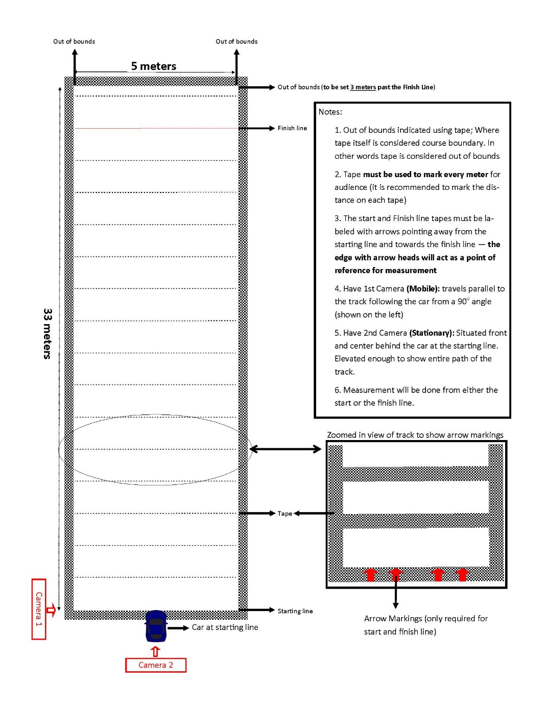

Figure 1: Performance course layout with Camera guidelines for Virtual Competition

- Race Logistics
  - A Chem-E-Car Competition® judge (or MC) will announce each team just prior to the start of their attempt.
  - Each car will have two (2) attempts to complete the course. Each attempt is limited to a two (2) minute time limited for the car to start and completely stop. Any car that does not stop within the two minutes will be disqualified for that attempt.
  - The best score of the two attempts will be used to determine the winner.
  - In the event that a team fails to show up on the starting line, or the vehicle fails to start, the next team in the order of the competition will be announced and requested to proceed to the starting line immediately.
  - The competition order will not change between the first and second rounds. There will be a short 15 minute break between rounds of the competition.

- Starting Line Procedure
  - The car must start moving, traverse the distance, and come to a stop within a 2 minute time interval.
  - At the starting line, 1 team member will be asked to head to the finish line. Team members are responsible for picking up their car after the distance is measured.
  - Once the car is placed on the starting line and the 2 minute time interval begins, all wheels must remain on the ground. Pushing the car or picking up the car/part of the car will result in a disqualification for that attempt.

- Competition Order Logistics
  - The distance and run order is announced one hour before the competition starts.
  - If a car is disqualified that was scheduled to start before your car, then you will move up one position in the starting order.
  - Five (5) minutes before the start of the competition, the first three (3) teams for each track are called to the start. The first team for each track will be at the starting line, the second team at the ready table, and the third team beginning to move to the “at ready” position.
  - The first team is given a one-minute warning before the competition starts.
  - The first team is given two (2) minutes for the car to start moving, traverse the distance and stop. When the car stops, the timer is reset for the next competitor.
  - The timing will also stop if the car travels out of bounds.
  - If the car does not stop within the two-minute period, then it is disqualified from that round of the competition.
  - After the car for team 1 stops, the distance traveled is measured. During the distance measurement, the next team is called and each team moves up one position.
  - After the distance is measured, the team members should take their car directly to the chemical disposal station to dispose of their spent chemicals.

- Vehicle Drive System
  - An objective of this contest is for students to demonstrate the ability to control a chemical reaction.
  - The only energy source for the propulsion of the car is a chemical reaction.
  - The distance a vehicle travels must also be controlled by a chemical reaction, based on a quantifiable change and direct control of the concentration of a chemical species.
  - This chemical reactant species must be a solid, liquid, or vapor.

- Vehicle Design
  - Vehicles entered into the competition must have a significant and demonstrable student design component, particularly with respect to the vehicle drive system, and the starting and stopping mechanisms.
  - Both the chemical reaction propelling the vehicle and the start/stop reaction (if there is one) must be physically on the vehicle during the competition (i.e., pre-loading of a drive system such as a capacitor assembly is not allowed).
  - The vehicle must be powered by a chemical reaction and must be stopped by a quantifiable change, and direct control, of the concentration of a chemical species.
  - This chemical reactant species must be a solid, liquid, or vapor.
  - Autonomous vehicle: The car must be an autonomous vehicle and cannot be controlled remotely. Pushing to start the vehicle or using a mechanical starting device is not allowed. “Bleeding” the time off at the starting line or prior to the starting line is prohibited. Raising the vehicle at the starting line to allow the wheels to begin turning is not allowed.
  - On-board computer control system (ex Arduino or Raspberry Pi unit) are allowed but must not in any way control/ measure the distance traveled. The program must be loaded onto the controller/computer/processor prior to the competition, and the settings may not be changed after the competition begins, which is defined as the time when the distance are announced.
  - Wired or wireless communication with the on-board computer/controller is not allowed once the competition begins and during the competition.
  - Teams may be asked to provide a copy of their complete programs to the rules committee on the competition day.
  - Encoders Teams are also not allowed to use an encoder to regulate the velocity of the vehicle in order to control the distance.
  - No Mechanical brakes: No mechanical force can be applied to the wheel, gears, driveshaft, etc., or ground to slow or stop the car (e.g. no brakes).
  - Mechanical or electronic timing devices: There can be no mechanical or electronic timing device(s) to stop the chemical reaction or stop the car. In addition, a timing device cannot utilize what is normally considered as an instantaneous reaction. For example, a constant or draining liquid feed to a sensing cell that employs an instantaneous reaction (such as acid-base or precipitation) would not be allowed. Another example would be a liquid draining out of a vessel to serve as a stop switch. This would be considered a mechanical timing device and would not be allowed.
  - ICE: Internal combustion engines using an alternative fuel (e.g., biodiesel, ethanol, etc.) are allowed. The fuel MUST be completely synthesized by the students (no additive blending is allowed). Succinct safety procedures for the maintenance and operation of this engine must be demonstrated by the team, with considerations to indoor operation. Internal combustion engines are not allowed to emit visible combustion smoke to the competition space and are subject to sound restrictions. See the Safety Rules for a more complete discussion.
  - Thermo-Electric Device (Power system): Thermo-electric thermopiles purchased from a manufacturer must be run with at least one side (hot or cold) controlled by a chemical reaction. NOTE: Phase changes (including melting and crystallization), mixing and dissolutions are not considered a chemical reaction.
  - Fuel Cells: Any vehicle that is purchased from a vendor without major modifications to its operation will be disqualified. For example a team could not purchase a fuel cell car and race this car without any modifications. Any team that purchases a commercial fuel cell or builds their own fuel cell must synthesize the fuel that is used; example, if the team purchases a commercial methanol fuel cell, they must synthesize the methanol and provide verification of their procedure. Hydrogen for fuel cells MUST be generated by a chemical reaction on site and or on the vehicle and not from a commercial device or pre-loaded canister. Appropriate process safety must be followed during fuel synthesis.
  - Commercial batteries: No commercial batteries of any kind (for example, AA batteries) are allowed as the power source. Commercial batteries are allowed for specialized instrumentation (e.g. detectors, sensors).

- Size of Car
  - All components of the car must fit into a box of dimensions no larger than 40 cm x 30 cm x 20 cm. The car may be disassembled to meet this requirement.
  - If the judges are uncertain whether the car will fit inside the box when dissembled, they may request that the team demonstrate that they can do this.

- Capital Cost of Vehicle:
  - The cost of the all vehicle components and the chemicals must not exceed $3500 USD. The vehicle cost includes the donated cost of any equipment.
  - The time donated by university machine shops and other personnel will not be included in the total price of the car. It is expected that every university has equal access to these resources.
  - The cost of pressure testing is also not included in the capital cost of the car.
  - The method used to estimate the donated cost of the equipment must be shown. It is expected that standard financial procedures will be used to estimate this cost.

- Changes to Car Design from Previous Years
  - Substantial changes must be made in both the propulsion system and stopping mechanism chemistry and indicated in the JSA form of the EDP. To be more specific: changing the acid in a sodium-bicarb and acid reaction is not considered to be a “substantial change”
  - Structural improvements are encouraged whenever necessary but will not be considered a significant enough change without a change to the propulsion system and stopping mechanism chemistry

- Team Member Status and Conduct
  - All team members must be active AIChE members and must be registered for the Regional Conference or Annual Student Conference.
  - Faculty and graduate students can only act as sounding boards to student queries. The faculty cannot be idea generators for the project.
  - There is no restriction on requesting assistance on vehicle safety – teams may request safety assistance from their faculty advisor, other faculty members, other universities, and professional practitioners in industry and elsewhere.
  - All questions posed by rules and safety judges at the safety inspection and poster session must be answered by the undergraduate student team members. The ability to explain car design, operation, safety and/or rules compliance is the responsibility of the undergraduate students.
  - The students working on the project must sign a statement saying they have read, understand, and abided by the rules. This statement must be included in the EDP.
  - For in-person: During the performance competition session, only five (5) team members are allowed in the pit area at once. Team members can be swapped out during the competition. For Virtual: During the performance competition session, teams are not limited to a specific number of team members that are allowed in the pit area.
  - All team members and the faculty advisor MUST have completed the required safety training course, which is available at www.aiche.org/chemecar. If team members have completed the certification in the previous calendar year, then they need not take the training again.
  - All student chapter teams that are competing in the Chem-E-Car Competition must have submitted a Student Chapter Annual Report online to AIChE. Note: New AIChE Student Chapter established after January 1, 2020 are exempt from this requirement.

- Winning Team and Awards
  - The winning team is the car that stops closest to the competition distance. This is defined as the absolute value of the distance between the front-most part of the car and the finish line, whether or not the car stops before or after the finish line.
  - In case of ties, the team with the best average from the two attempts may be declared the winner.
  - Winners of the Chem-E-Car Performance Competition will be known immediately following the performance competition.

- Onsite Safety Judges and Rules Coordinators: If there is any uncertainty on an issue of safety or other judging criteria, please contact the Chem-E-Car Committee. The decisions of the onsite rules and safety judges are final.

